U2

‘SONGS OF SURRENDER’

40 SONGS

RE-RECORDED AND RE-IMAGINED

OUT MARCH 17th 2023

TRAILER HERE

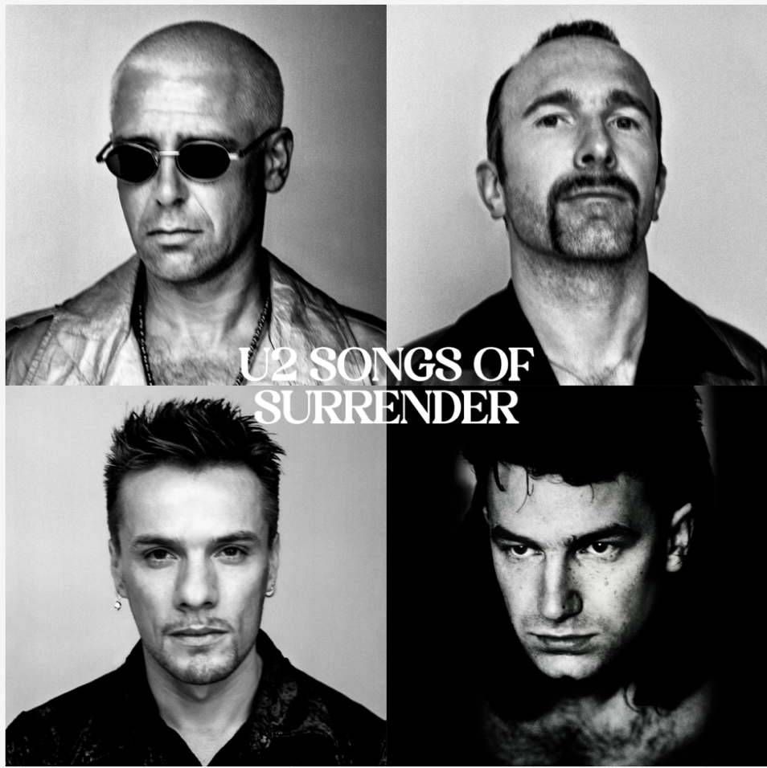

FIRST TRACK

‘Pride (In the Name of Love)’

Listen Here

(January 11, 2023) - Island Records and Interscope today announce the release of Songs Of Surrender – a collection of 40 seminal U2 songs from across the band’s catalog, re-recorded and reimagined for 2023 in sessions spanning the last two years, to be released in full on Friday March 17th. The first track to be made available from this brand new set of recordings is the anthemic ‘Pride (In The Name Of Love)’, listen here.

Songs Of Surrender is curated and produced by The Edge and sees the band revisit some of the most celebrated songs of their 40+ year career, including ‘With Or Without You’, ‘One’, ‘Beautiful Day’, ‘Sunday Bloody Sunday’ and ‘Invisible’, for a musical reimagining resulting in a completely new recording of each track, to include the arrangements and, in some cases, new lyrics.

The Edge said of the project: “Music allows you to time travel, and we became curious to find out what it would be like to bring our early songs back with us to the present day and give them the benefit, or otherwise, of a 21st century reimagining.

What started out as an experiment quickly developed into a personal obsession as so many of our songs yielded to a new interpretation. Intimacy replaced post punk urgency. New tempos, new keys, and in some cases new chords and new lyrics arrived. A great song, it turns out is kind of indestructible.

The process of selecting which songs to revisit started with a series of demos. I looked at how a song would hang together if all but the bare essential elements were taken away. The other main aim was to find ways to bring intimacy into the songs, as most of them were originally written with live concert performance in mind.

Reviewing these sketch recordings with producer Bob Ezrin, it was very easy to see the ones that worked straight off the bat and those that needed more work. We all got into the sensibility of less is more.”

The 40 newly recorded tracks are collected together under each of the four bandmember names across four separate ‘albums’, with The Edge adding – “Hearing the songs interact, and finding the running orders for the four albums was really thrilling; finding the surprising segues, getting a chance to DJ. Once we had four distinct albums it was easy to see who would be the figurehead for each one.”

The complete Songs Of Surrender track listing is:

Side 1 – The Edge
1. One
2. Where The Streets Have No Name
3. Stories For Boys
4. 11 O'Clock Tick Tock
5. Out Of Control
6. Beautiful Day
7. Bad
8. Every Breaking Wave
9. Walk On (Ukraine)
10. Pride (In The Name Of Love)

Side 2 - Larry
1. Who’s Gonna Ride Your Wild Horses
2. Get Out Of Your Own Way
3. Stuck In A Moment You Can’t Get Out Of
4. Red Hill Mining Town
5. Ordinary Love
6. Sometimes You Can’t Make It On Your Own
7. Invisible
8. Dirty Day
9. The Miracle Of Joey Ramone
10. City Of Blinding Lights

Side 3 - Adam
1. Vertigo
2. I Still Haven’t Found What I’m Looking For
3. Electrical Storm
4. The Fly
5. If God Will Send His Angels
6. Desire
7. Until The End Of The World
8. Song For Someone
9. All I Want Is You
10. Peace On Earth

Side 4 - Bono
1. With Or Without You
2. Stay
3. Sunday Bloody Sunday
4. Lights Of Home
5. Cedarwood Road
6. I Will Follow
7. Two Hearts Beat As One
8. Miracle Drug
9. The Little Things That Give You Away
10. 40

Songs Of Surrender is available in the following formats: Full 40 track Digital; Limited Edition 40 track 2 x CD Hardback Deluxe; and Limited Edition 40 track 4 x Vinyl. Pre order now HERE.

Download press images here: www.U2.com/rmpphoto

For enquiries, please contact RMP:
Kristen Foster – Full Coverage Communications -- Kristen.Foster@fullcov.com
Christine Wolff - Interscope Records -- Christine.Wolff@unusic.com

‎www.U2.com

